Use Case Specification

DMT/RM01/TMP

|  |  |
| --- | --- |
| Project Code | BANK_EXAM_111 |
| Project Name | BANK EXAM PORTAL |

|  |  |  |
| --- | --- | --- |
| Prepared/Modified by | Role | Date of Preparation |
| JOE | Test Engineer | 05/09/2018 |
| Reviewed by | Role | Date of Review |
| NEHA | SME | 05/09/2018 |
| Approved by | Role | Date of Approval |
| SHWETHA | Test Manager | 05/09/2018 |
| Circulation List |  | Version Number of the template: |
| Version Number | 1 |  |

<<Customer>> REVIEW HISTORY

<<Customer comments on the Use case along with the signed off is tracked here>>

|  |  |  |  |  |  |  |
| --- | --- | --- | --- | --- | --- | --- |
| Version | <<Version number>> |  |  |  |  |  |
| Date | <<Date of Review>> |  |  |  |  |  |
| Reviewed by | << Reviewer Name>> |  |  |  |  |  |
| Reviewed UI Specification doc | << Whether UI Specification doc is reviewed >> |  |  |  |  |  |
| All Open Queries/issues closed | << Whether all the open queries and issues resolved>> |  |  |  |  |  |
| Agreement on Assumptions | <<Whether all the assumptions have been agreed upon by the customer>> |  |  |  |  |  |
| Sign Off | <<Signature>> |  |  |  |  |  |

Disclaimer:

The scope of the project ‘<<Project Name>>’ is restricted to the contents of this signed off use case.

TABLE OF CONTENTS

Use Case Name: BANKING EXAM PORTAL 4

Actor(s) 4

Preconditions - Admin. 4

Flow of Events 4

4.1 Basic Flow 4

4.2 Alternative Flows 5

Alternate Flow 1: Successful Exam Addition 5

Alternate Flow 2: Successful Exam Addition 5

Exceptional Flow 6

Exceptional Flow 1: Unsuccessful Exam Addition 6

Exceptional Flow 2: Unsuccessful Exam Addition due to invalid date 6

Exception Flow 3: Web Server Down 6

Exception Flow 4: Database Connectivity Error 7

Exception Flow 5: Network Connectivity Error 7

Post Conditions 7

Special Requirements 8

Performance 8

Availability 8

Business Rules 8

Diagrams 9

Use Case Diagram 9

1. For Successful Addition of Exam 9

2. FOR SUCCESFULL USER REGISTRATION 10

Success Scenarios 11

Failure Scenarios 11

Issues 11

UI Specifications 11

Assumptions 11

Use Case Name: BANKING EXAM PORTAL

Use Case ID: BANK_EXAM_111

**Brief Description:** This usecase shows the process of using Banking Exam Portal for applying for various Banking Exams.

Actor(s)

1. Admin.

2. User

3. Bank Exam Portal

Preconditions - Admin.

1. Administrator is an employee of a Banking Exam Portal company.

2. Administrator has an access to the Banking Exam Portal Website.

3. Administrator has a valid user id and a password.

Flow of Events

4.1 Basic Flow

**Name:** Successful login.

1. Administrator visits the website **www.bankersjob.com/exam** using browser.
2. Administrator enters user-id and password.
3. Administrator clicks submit button.
4. On successful login, Admin home page is displayed.

**Name:** Adding an Exam

1. Admin clicks on the Add Exam Details link available in Home Page.
2. Admin enters exam name.
3. Admin enters exam code Bank name.
4. Admin selects online registration commencement date.
5. Admin selects online registration closure date.
6. Admin selects exam date.
7. Admin add description about exam.
8. Admin adds Exam fees payable.
9. Admin clicks on submit button.
10. System displays the message ”Exam Added Successfully”.

* 1. Alternative Flows

Alternate Flow 1: Successful Exam Addition

**Name:** Adding an Exam

1. Administrator clicks on the Add Exam Details link available on the Admin Home Page.
2. Admin enters exam name.
3. Admin changes exam code Bank name.
4. Admin selects online registration commencement date.
5. Admin selects online registration closure date.
6. Admin selects exam date.
7. Admin add description about exam.
8. Admin adds Exam fees payable.
9. System displays the message ”Exam Added Successfully”.

Alternate Flow 2: Successful Exam Addition

**Name:** Adding an Exam

1. Administrator clicks on the Add Exam Details link available on the Admin Home Page.
2. Admin entersexam name.
3. Admin enters exam code Bank name.
4. Admin selects online registration commencement date.
5. Admin selects online registration closure date.
6. Admin change exam date.
7. Admin add description about exam.
8. Admin adds Exam fees payable.
9. System displays the message ”Exam Added Successfully”.

Exceptional Flow

Exceptional Flow 1: Unsuccessful Exam Addition

**Name**: Adding an Exam

1. Admin clicks on the Add Exam Details link available on the Admin Home Page.
2. Admin leaves exam name blank.
3. Admin enters exam code Bank name.
4. Admin selects online registration commencement date.
5. Admin selects online registration closure date.
6. Admin enters exam date.
7. Admin add description about exam.
8. Admin adds Exam fees payable.
9. System displays the message ”Exam Name is Blank”.

Exceptional Flow 2: Unsuccessful Exam Addition due to invalid date

**Name**: Adding an Exam

1. Administrator clicks on the Add Exam Details link available on the Admin Home Page.
2. Admin enters exam name.
3. Admin enters exam code Bank name.
4. Admin selects online registration commencement date.
5. Admin selects online registration closure date.
6. Admin enters invalid exam date.
7. Admin add description about exam.
8. Admin adds Exam fees payable.
9. System displays the message ”Invalid Exam Date”.

Exception Flow 3: Web Server Down

**Name**: Adding an Exam

1. Administrator clicks on the Add Exam Details link available on the Admin Home Page.
2. Admin enters exam name.
3. Admin enters exam code Bank name.
4. Admin selects online registration commencement date.
5. Admin selects online registration closure date.
6. Admin enters exam date.
7. Admin add description about exam.
8. Admin adds Exam fees payable.
9. The system displays an error message regarding web server unavailability problem.

Exception Flow 4: Database Connectivity Error

**Name**: Adding an Exam

1. Administrator clicks on the Add Exam Details link available on the Admin Home Page.
2. Admin enters exam name.
3. Admin enters exam code Bank name.
4. Admin selects online registration commencement date.
5. Admin selects online registration closure date.
6. Admin enters exam date.
7. Admin add description about exam.
8. Admin adds Exam fees payable.
9. The system displays an error message regarding database connectivity problem.

Exception Flow 5: Network Connectivity Error

**Name**: Adding an Exam

1. Administrator clicks on the Add Exam Details link available on the Admin Home Page.
2. Admin enters exam name.
3. Admin enters exam code Bank name.
4. Admin selects online registration commencement date.
5. Admin selects online registration closure date.
6. Admin enters exam date.
7. Admin add description about exam.
8. Admin adds Exam fees payable.
9. The system displays an error message regarding network connectivity problem.

Post Conditions

| Flow Name | Post Condition |
| --- | --- |
| Successful Exam Addition | System displays the message ”Exam has been Added Successfully”. |
| Unsuccessful Exam Addition | System displays the message ”Exam Name is left Blank”. |
| Unsuccessful Exam Addition due to invalid date | System displays the message ”Invalid Exam Date has been entered ”. |
| Web Server Down | The system should display an error message to the user regarding web server unavailability problem |
| Database Connectivity Error | The system should display an error message to the user regarding the database connectivity problem |
| Network Connectivity Error | The system should display an error message to the user regarding the network connectivity problem |

Special Requirements

Performance

The applicant should receive the mail having the details of the Exam date and time.

Availability

* 1. Website is up and running 24*7.

Business Rules

| Business Rule Name | Business Rule Description | System action (if BR fails) |
| --- | --- | --- |
| BR01 | Only 5 Bank Codes must be available in the select option. | Error message is displayed if not selected |
| BR02 | The date of the exam should be after the application closure date | Error message is displayed if proper date is not selected |
| BR03 | Exam date should not be on Sundays and govt. holidays. | Error message is displayed if proper date is not selected |
| BR04 | Exam names should be distinct | Error message is displayed if same names are entered |

Diagrams

Use Case Diagram

* 1. For Successful Addition of Exam

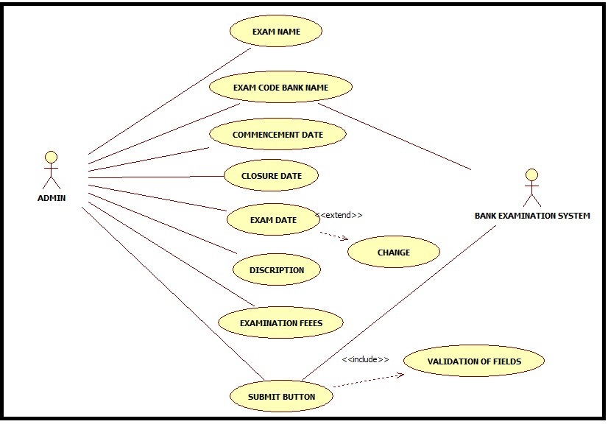

* 1. fOR SUCCESFULL USER REGISTRATION

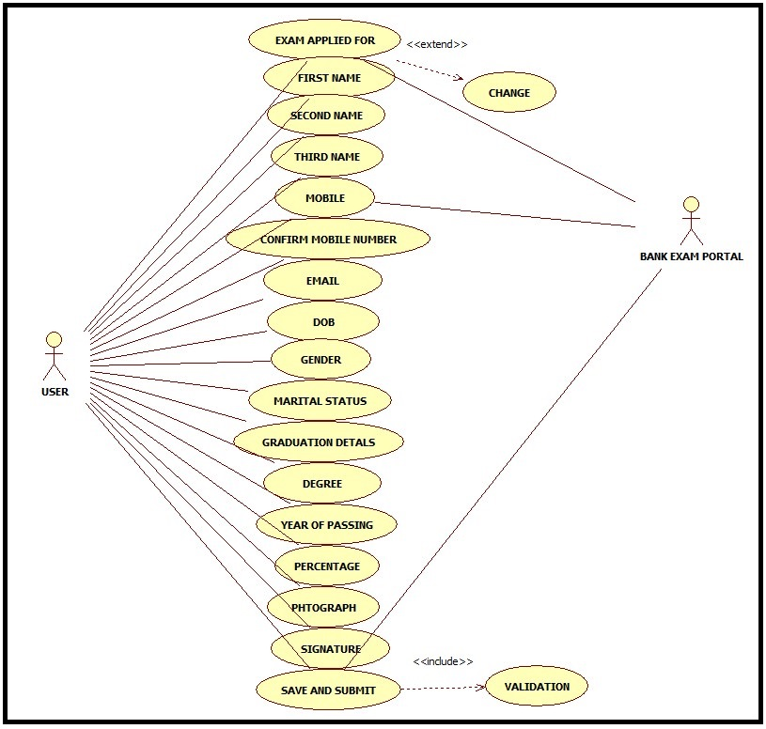

Scenarios

Success Scenarios

* Successful submission of Exam Application.

Failure Scenarios

* Failed addition of Exam due to leaving a field blank.
* Failed addition of Exam Application due to entering wrong exam date
* Failed addition of Exam Application due to entering invalid bank code.
* Failed addition of Exam Application due to network error.

Issues

1. What is to be done if web server is down?
2. What is to be done if there is data connectivity error?

UI Specifications

Assumptions

1. Only Administrator can avail this service.
2. Only admin can manipulate the fields

REVISION HISTORY OF THE WORK PRODUCT

<to be maintained by projects>

|  |  |  |  |  |  |
| --- | --- | --- | --- | --- | --- |
| # | Date | Version # | Section Changed | Details of changes made | Approved By |
| 1 |  |  |  |  |  |
| 2 |  |  |  |  |  |